Demo 3 – getimg.ai Inpainting
Goal: Demonstrate how to edit an existing photo by adding or changing objects using getimg.ai’s Inpainting feature.

3.1 Access the image editor
- Visit https://getimg.ai/features/inpainting. Click Start inpainting now or Edit my image now. If prompted, sign in with Google.
- The page explains that getimg’s inpainting process involves three steps: upload your image, mask and describe the changes, then generate a new version.

3.2 Upload the image of a graduating man
- In the Image Editor, click Upload and choose a photo of a graduating man wearing robes but without a cap. The image will appear on the canvas.
- Ensure Inpainting is selected from the tool options (look for an Inpainting tab or icon). The interface displays a brush or masking tool.

3.3 Add a graduation cap
- Use the mask brush to highlight the area above the graduate’s head where the cap should appear. Try to cover only the area that needs editing—smaller masks (less than 30–40 % of the image) produce better result.
- In the Description box (or prompt field), type “black graduation cap”. This instructs the AI to fill the masked area with a cap.
- Click Generate. In a few seconds, the right panel shows an updated version with a cap seamlessly blended into the image.

3.4 Extend the robe to cover the legs
- Select the mask tool again and paint over the visible legs or the lower part of the image where the robe should be extended.
- In the prompt box, write “extend the graduation robe to cover the legs” or similar. Be concise—getimg.ai recommends simple words or phrases to describe changes.
- Click Generate. The AI fills in a longer robe that blends naturally with the original garment.
- Review the result. If needed, undo and refine the mask or adjust the description for better alignment. You can continue experimenting with different prompts and masks to perfect the edit.

3.5 Discussion points
- getimg.ai’s inpainting tool uses a user‑friendly interface: upload, mask, describe and generate. Edits happen in seconds.
- Encourage participants to use simple descriptions and to keep masked areas relatively small for best results.
- Remind them that the tool deducts credits for each generation; free users receive a daily allocation.

In case you lose where the inpainting is:
- Click on image editor
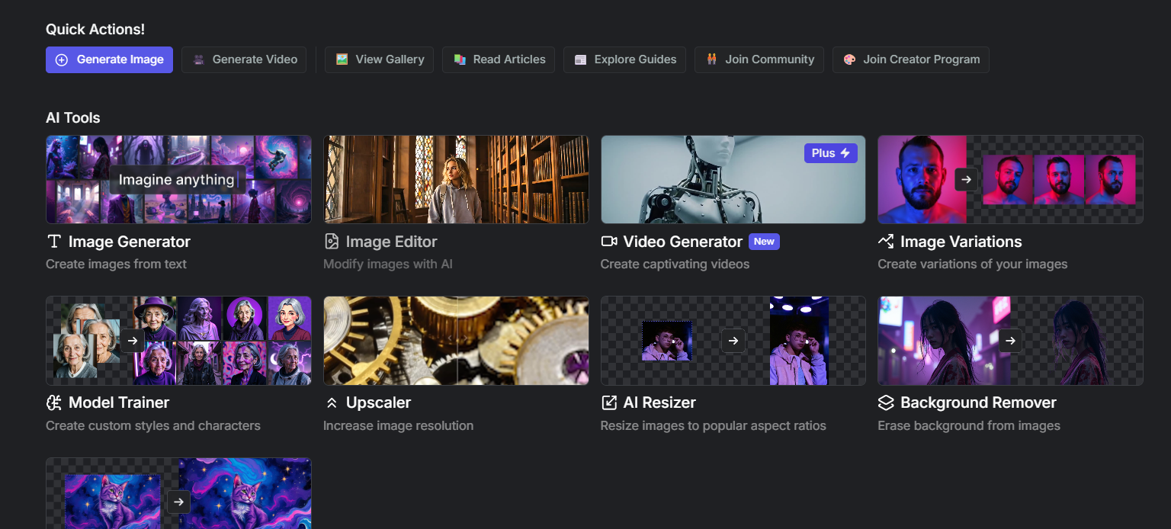
- Click on the menu an select inpaint
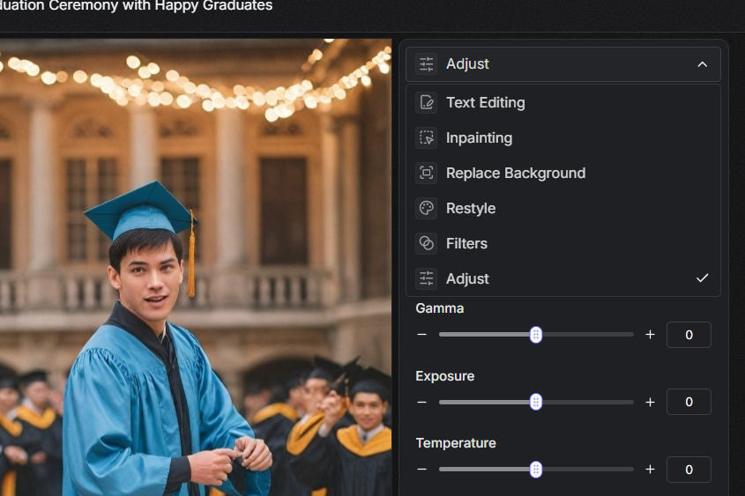
- Here is where you select the masking region
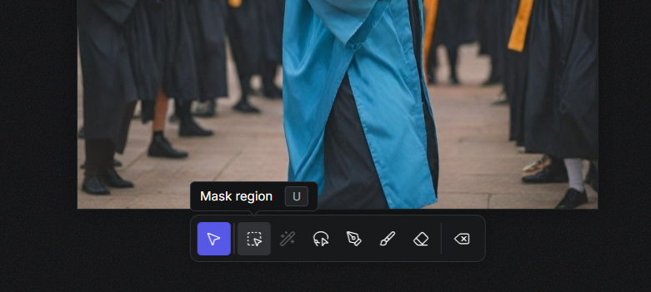
- And then you add your prompt here
